CADERNO MÓDULOS COLETIVO

2025

Nome: __________________________________ MASP:__________

1. CALENDÁRIO ESCOLAR 4
2. INFORMAÇÕES GERAIS 6
3. HORÁRIO 7
4. MÓDULO INDIVIDUAL 8
5. MATRIZ CURRICULAR 9
6. EMENTA 10
7. CALENDÁRIO MENSAL DE EVENTOS 14
EEPSAS – FEVEREIRO 14
EEPSAS – MARÇO 15
EEPSAS – ABRIL 16
EEPSAS – MAIO 17
EEPSAS – JUNHO 18
EEPSAS – JULHO 19
EEPSAS – AGOSTO 20
EEPSAS – SETEMBRO 21
EEPSAS – OUTUBRO 22
EEPSAS – NOVEMBRO 23
EEPSAS – DEZEMBRO 24
8. MÓDULOS COLETIVOS 25

CALENDÁRIO ESCOLAR
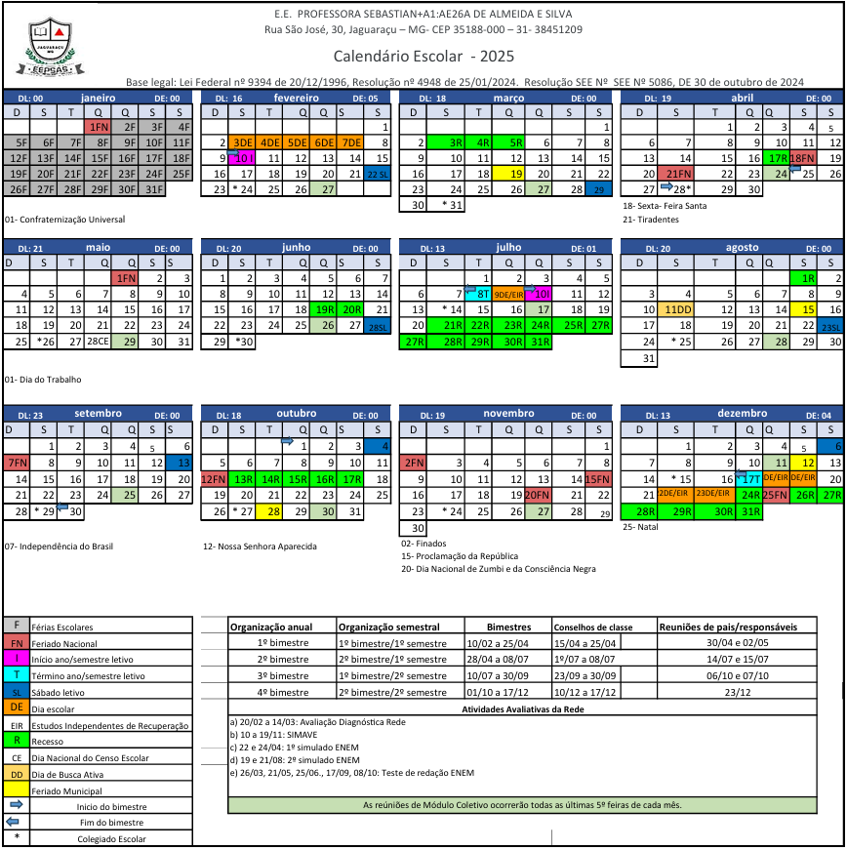

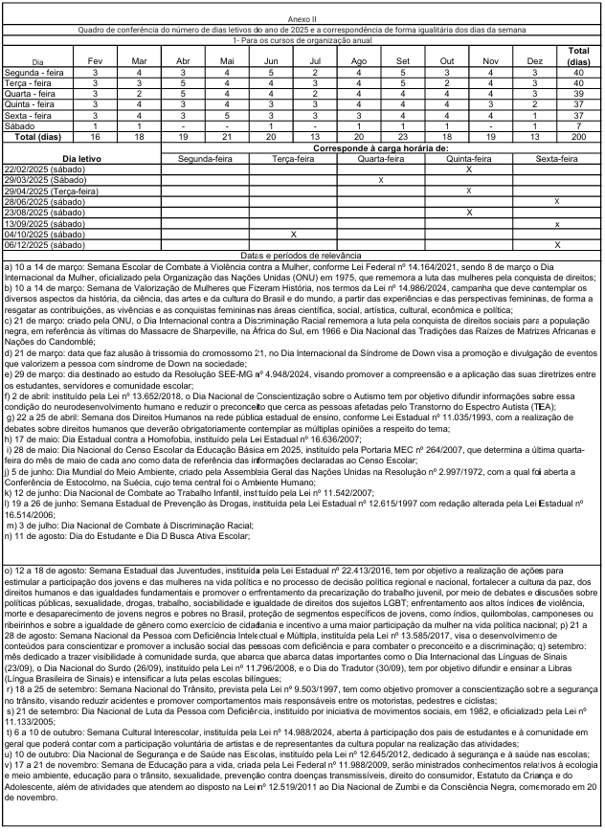

INFORMAÇÕES GERAIS
Dias Letivos: 200
Semanas Letivas: 10 semanas por etapa
Etapas Letivas: 04
Módulo-Aula: 50 minutos

Etapas Letivas:
Etapa | Valor | Início | Fim | Dias
1º Bimestre | 25 pts. | 10/02 | 25/04 | 50
2º Bimestre | 25 pts. | 28/04 | 08/07 | 50
3º Bimestre | 25 pts. | 10/07 | 30/09 | 50
4º Bimestre | 25 pts. | 01/10 | 17/12 | 05
TOTAL | 100 pts. |  |  | 200 dias

Distribuição de pontos:
____ ETAPA
Descrição | Valor
Total
____ ETAPA
Descrição | Valor
Total

____ ETAPA
Descrição | Valor
Total

____ ETAPA
Descrição | Valor
Total

HORÁRIO
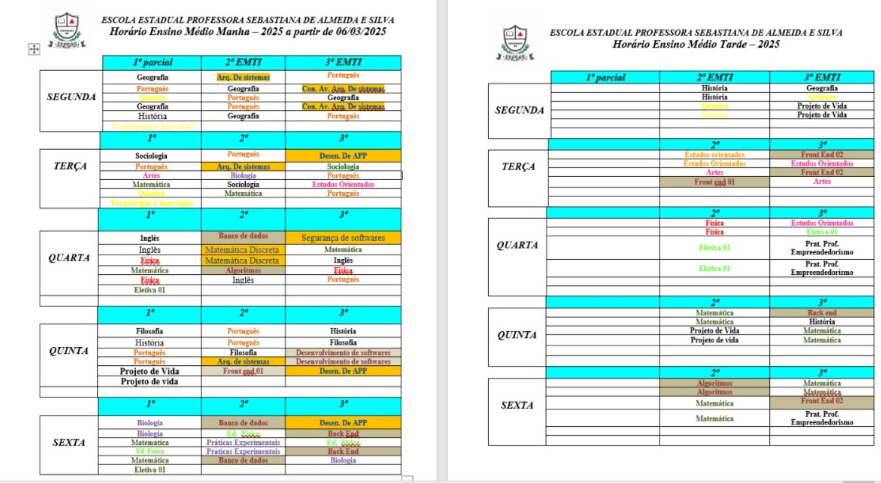


MÓDULO INDIVIDUAL
Horário | Segunda | Terça | Quarta | Quinta | Sexta
07:00 | BERNARDO |  | X |  | X
07:50 | BERNARDO |  | X |  | X
08:40 | BERNARDO |  | X | X | X
09:45 | BERNARDO |  | X | X | X
10:35 | BERNARDO |  |  | X | X
12:50 |  | X |  | X | X
13:40 |  |  |  | X | X
14:45 |  | X |  | X | X
15:35 |  | X |  | X
18:00 | X | X |  | MÓDULO COLETIVO ULTIMA QUINTA DO MES | X
18:50 | X | X |  | MÓDULO COLETIVO ULTIMA QUINTA DO MES | X
19:40 | X | X |  | MÓDULO COLETIVO ULTIMA QUINTA DO MES | X
20:45 | X |  |  | MÓDULO COLETIVO ULTIMA QUINTA DO MES | X
21:35 | X |  |  | MÓDULO COLETIVO ULTIMA QUINTA DO MES | X

TABELA DE CARGA HORÁRIO DE MÓDULOS A SER
CUMPRIDA PELO PROFESSOR

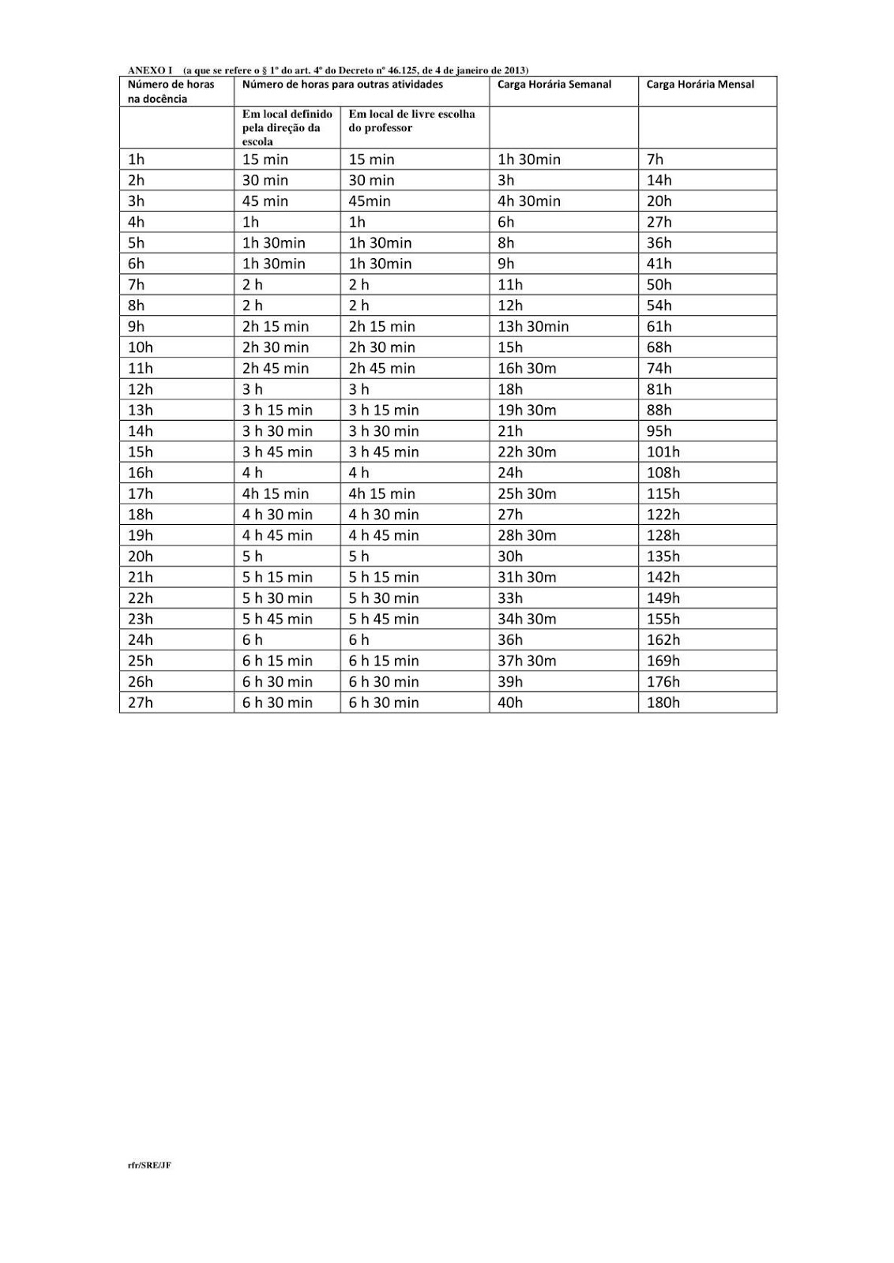

MATRIZ CURRICULAR
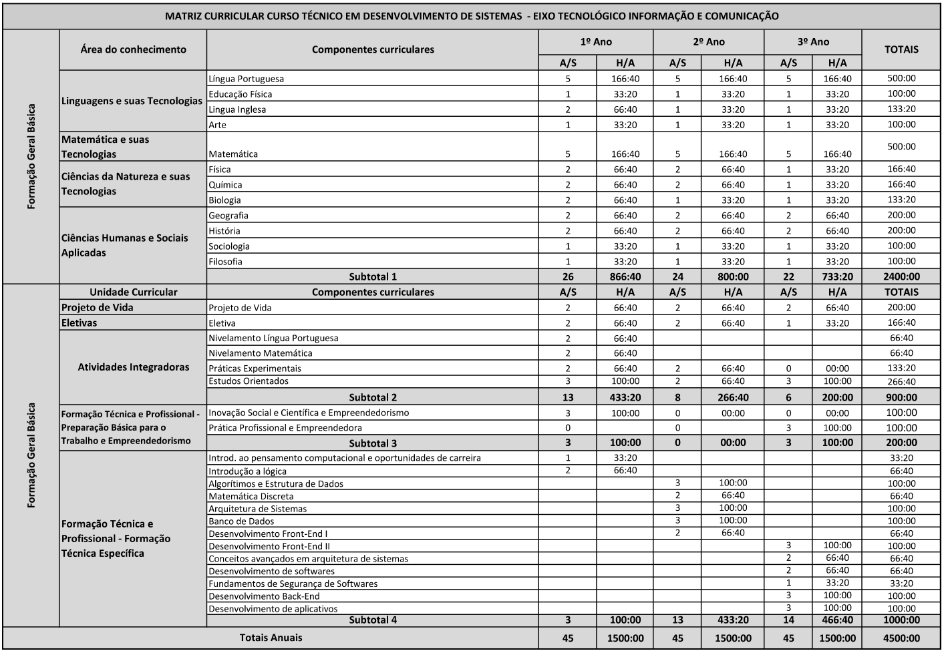

EMENTA
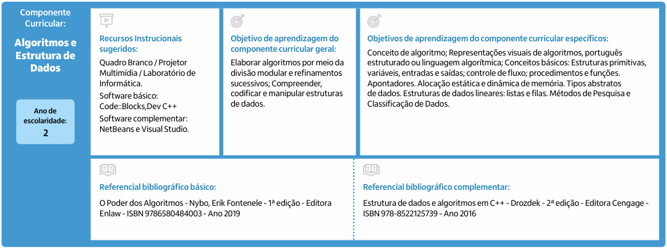
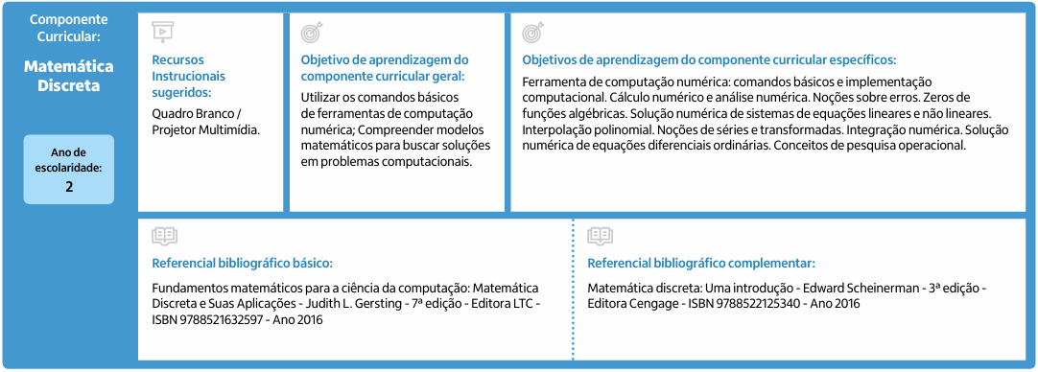
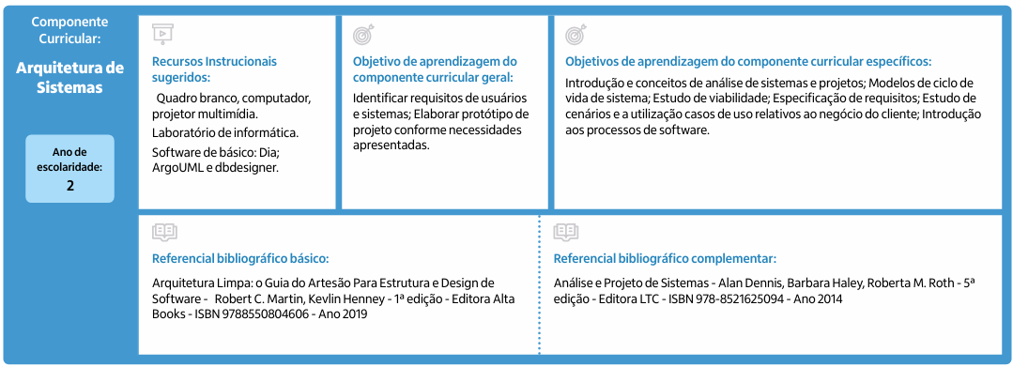

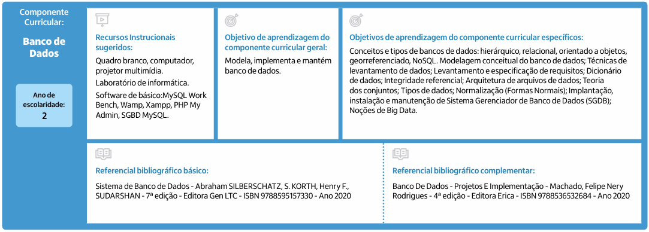
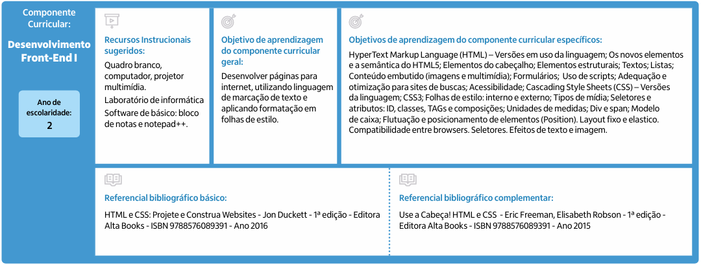
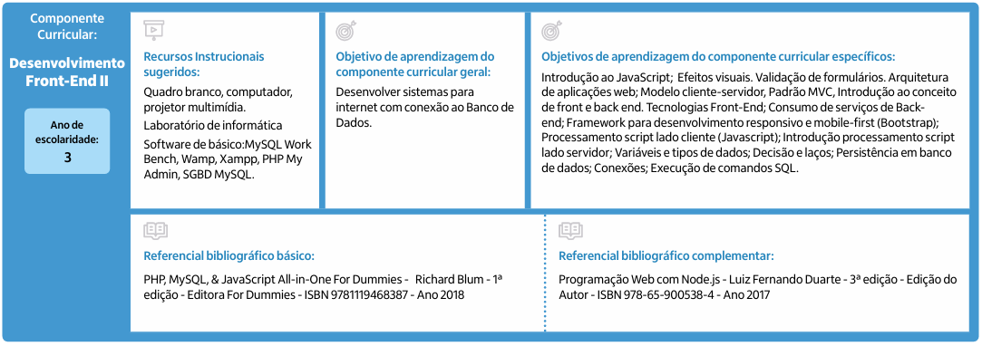
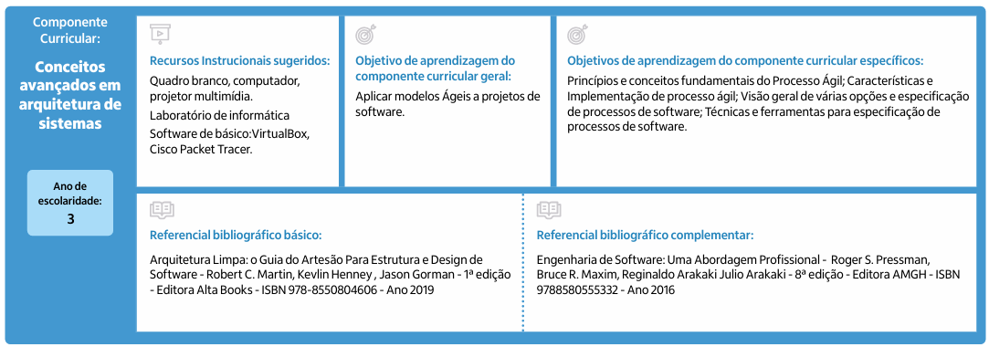
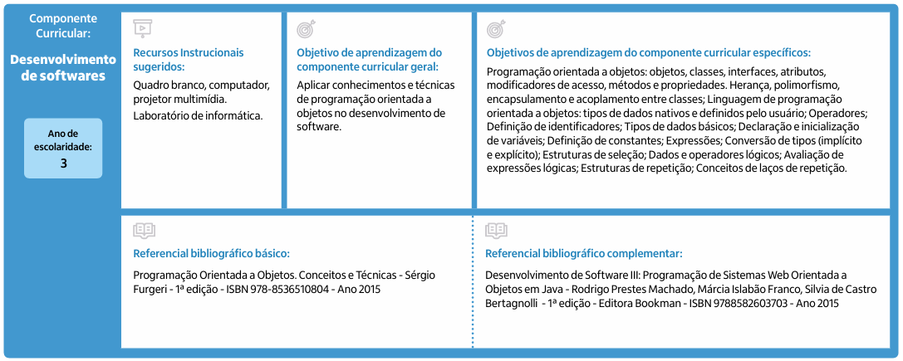
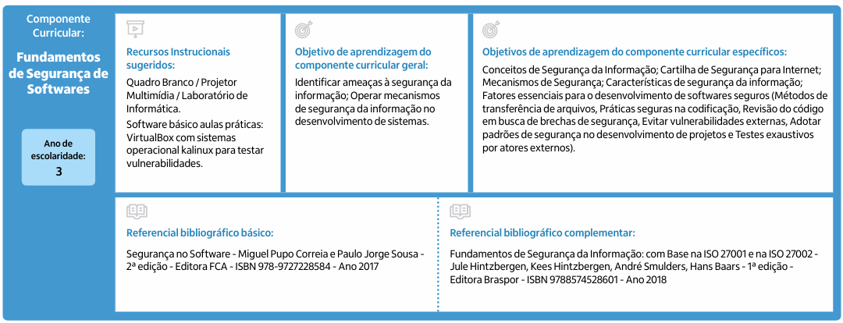
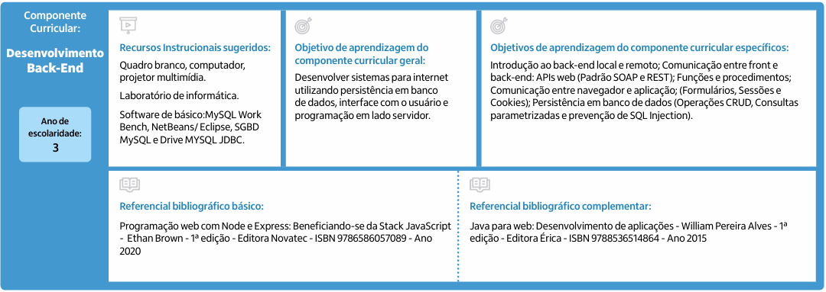
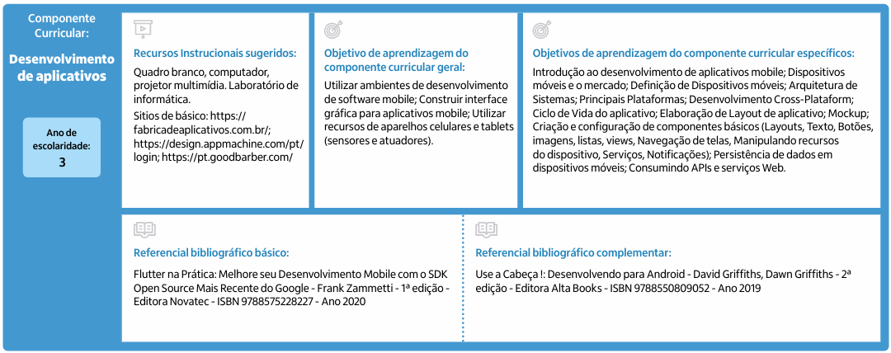

CALENDÁRIO MENSAL DE EVENTOS

EEPSAS – FEVEREIRO
Observações Gerais: |  |  |  |  | 2025
16 Dias Letivos  Segundas Terças Quartas Quintas Sextas  03 03 03 04 03  * Sábado Letivo 29/03: Quinta-Feira |  |  |  |  | Início do 1º Bimestre: 10/02  Colegiado Escolar: 24/02  Módulo Coletivo: 27/02
Domingo | Segunda-feira | Terça-feira | Quarta-feira | Quinta-feira |  | Sexta-feira | Sábado
 |  |  |  |  |  |  | 1
2 | 3 - Dia Escolar | 4 - Dia Escolar | 5 - Dia Escolar | 6 - Dia Escolar |  | 7 - Dia Escolar | 8
09 | 10 | 11 | 12 | 13 |  | 14 | 15
 | Início do 1º Bimestre
16 | 17 | 18 | 19 | 20 |  | 21 | 22 - Quinta
23 | 24 | 25 | 26 | 27 |  | 28
 | Colegiado Escolar |  |  | Módulo Coletivo

EEPSAS – MARÇO
Observações Gerais: |  |  |  |  | 2025
18 Dias Letivos  Segundas Terças Quartas Quintas Sextas  04 03 03* 04 04  * Sábado Letivo 29/03: Quarta Feira |  |  |  |  | Recesso de Carnaval: 03/03 a 05/03  Módulo Coletivo: 27/03  Colegiado Escolar: 31/03
Domingo | Segunda-feira | Terça-feira | Quarta-feira | Quinta-feira |  | Sexta-feira | Sábado
 |  |  |  |  |  |  | 1
2 | 3 - Recesso | 4 - Recesso | 5 - Recesso | 6 |  | 7 | 8
 | CARNAVAL | CARNAVAL | CARNAVAL
09 | 10 | 11 | 12 | 13 |  | 14 | 15
16 | 17 | 18 | 19 – F. Municipal | 20 |  | 21 | 22
 |  |  | DIA DE SÃO JOSÉ
23 | 24 | 25 | 26 | 27 |  | 28 | 29 - Quarta
 | Provas | Provas | Provas  Redação Enem | Provas  Módulo Coletivo |  | Provas | Provas
30 | 31
 | Colegiado Escolar

EEPSAS – ABRIL
Observações Gerais: |  |  |  |  | 2025
19 Dias Letivos  Segundas Terças Quartas Quintas Sextas  03 04* 05 04* 03  * Terça 29/04: Será horário de uma Quinta-Feira. |  |  |  |  | Recesso Semana Santa: 17/04 a 21/04  Módulo Coletivo: 24/03  Fim do 1º Bimestre: 25/04  Colegiado Escolar e Início do 2º Bimestre: 28/03
Domingo | Segunda-feira | Terça-feira | Quarta-feira | Quinta-feira |  | Sexta-feira | Sábado
 |  | 1 | 2 | 3 |  | 4 | 5
6 | 7 | 8 | 9 | 10 |  | 11 | 12
 | Provas | Provas | Provas | Provas |  | Provas
13 | 14 | 15 | 16 | 17 - Recesso |  | 18 - Feriado | 19
 | Recuperação | Recuperação | Recuperação |  |  | SEXTA FEIRA DA PAIXÃO
20 | 21 - Feriado | 22 | 23 | 24 |  | 25 | 26
 | Inconfidência Mineira | Simulado Enem | Simulado Enem | Simulado Enem  Módulo Coletivo |  | Fim do 1º Bimestre
27 | 28 | 29 - *Quinta | 30
Colegiado Escolar
Início do 2º Bimestres

EEPSAS – MAIO
Observações Gerais: |  |  |  |  | 2025
21 Dias Letivos  Segundas Terças Quartas Quintas Sextas  04 04 04 04 05 |  |  |  |  | Dia do Trabalhador: 01/05  Colegiado Escolar: 26/05  Dia do Censo: 28/05  Módulo Coletivo: 29/05
Domingo | Segunda-feira | Terça-feira | Quarta-feira | Quinta-feira |  | Sexta-feira | Sábado
 |  |  |  | 1 - Feriado |  | 2 | 3
 |  |  |  | Dia do Trabalhador
4 | 5 | 6 | 7 | 8 |  | 9 | 10
11 | 12 | 13 | 14 | 15 |  | 16 | 17
18 | 19 | 20 | 21 | 22 |  | 23 | 24
25 | 26 | 27 | 28 | 29 |  | 30 | 31
 | Colegiado Escolar |  | Censo Escolar | Módulo Coletivo

EEPSAS – JUNHO
Observações Gerais: |  |  |  | 2025
20 Dias Letivos  Segundas Terças Quartas Quintas Sextas  05 04 04 03 04*  *Sábado Letivo 28/06: Sexta-Feira. |  |  |  | Recesso de Corpus Christi: 19/06 e 20/06  Módulo Coletivo: 26/06  Colegiado Escolar: 30/06
Domingo | Segunda-feira | Terça-feira | Quarta-feira | Quinta-feira | Sexta-feira | Sábado
1 | 2 | 3 | 4 | 5 | 6 | 7
8 | 9 | 10 | 11 | 12 | 13 | 14
15 | 16 | 17 | 18 | 19 - Recesso | 20 - Recesso | 21
 |  |  |  | Corpus Christi | Corpus Christi
22 | 23 | 24 | 25 | 26 | 27 | 28 - Sexta
 |  |  |  | Módulo Coletivo
29 | 30
 | Colegiado Escolar

EEPSAS – JULHO
Observações Gerais: |  |  |  |  | 2025
13 Dias Letivos  Segundas Terças Quartas Quintas Sextas  02 03 02 03 03 |  |  |  |  | Fim do 2º Bimestre: 08/07  Dia Escolar: 09/07  Início do 3º Bimestre: 10/07  Módulo Coletivo: 17/06  Férias Escolares: 21/07 a 01/08
Domingo | Segunda-feira | Terça-feira | Quarta-feira | Quinta-feira |  | Sexta-feira | Sábado
 |  | 1 | 2 | 3 |  | 4 | 5
6 | 7 | 8 | 9 - Dia Escolar | 10 |  | 11 | 12
 |  | Fim do 2º Bimestre | Estudos Independentes  Recuperação | Início do 3º Bimestre
13 | 14 | 15 | 16 | 17 |  | 18 | 19
 | Colegiado Escolar |  |  | Módulo Coletivo
20 | 21 - Recesso | 22 - Recesso | 23 - Recesso | 24 - Recesso |  | 25 - Recesso | 26
27 | 28 - Recesso | 29 - Recesso | 30 - Recesso | 31 - Recesso

EEPSAS – AGOSTO
Observações Gerais: |  |  |  |  | 2025
20 Dias Letivos  Segundas Terças Quartas Quintas Sextas  04 04 04 05* 04  *Sábado Letivo 23/08: Quinta-Feira. |  |  |  |  | Assunção de Nossa Senhora: 15/08  Colegiado Escolar: 25/08  Módulo Coletivo: 28/08
Domingo | Segunda-feira | Terça-feira | Quarta-feira | Quinta-feira |  | Sexta-feira | Sábado
 |  |  |  |  |  | 1 - Recesso | 2
3 | 4 | 5 | 6 | 7 |  | 8 | 9
10 | 11 | 12 | 13 | 14 |  | 15 – F. Municipal | 16
 |  |  |  |  |  | ASSUNÇÃO DE NOSSA SENHORA
17 | 18 | 19 | 20 | 21 |  | 22 | 23 - Quinta
24 | 25 | 26 | 27 | 28 |  | 29 | 30
 | Colegiado Escolar |  |  | Módulo Coletivo
31

EEPSAS – SETEMBRO
Observações Gerais: |  |  |  |  | 2025
23 Dias Letivos  Segundas Terças Quartas Quintas Sextas  05 05 04 04 05*  *Sábado Letivo 13/09: Sexta-Feira. |  |  |  |  | Independência do Brasil: 07/09  Módulo Coletivo: 25/09  Colegiado Escolar: 29/09  Fim do 3º Bimestre: 30/09
Domingo | Segunda-feira | Terça-feira | Quarta-feira | Quinta-feira |  | Sexta-feira | Sábado
 | 1 | 2 | 3 | 4 |  | 5 | 6
7 – Feriado | 8 | 9 | 10 | 11 |  | 12 | 13 - Sexta
INDEPEDÊNCIA
DO BRASIL
14 | 15 | 16 | 17 | 18 |  | 19 | 20
21 | 22 | 23 | 24 | 25 |  | 26 | 27
 |  |  |  | Módulo Coletivo
28 | 29 | 30
 | Colegiado Escolar | Fim do 3º Bimestre

EEPSAS – OUTUBRO
Observações Gerais: |  |  |  |  | 2025
18 Dias Letivos  Segundas Terças Quartas Quintas Sextas  03 03* 04 04 04  *Sábado Letivo 04/10: Terça-Feira. |  |  |  |  | Início do 4º Bimestre  Dia de Nossa Senhora: 12/10  Semana da Criança: 13/10 a 17/10  Colegiado Escolar: 27/10  Módulo Coletivo: 30/10
Domingo | Segunda-feira | Terça-feira | Quarta-feira | Quinta-feira |  | Sexta-feira | Sábado
 |  |  | 1 | 2 |  | 3 | 4 - Terça
 |  |  | Início do 4º Bimestre
5 | 6 | 7 | 8 | 9 |  | 10 | 11
12 - Feriado | 13 – Recesso | 14 – Recesso | 15 – Recesso | 16 – Recesso |  | 17 – Recesso | 18
Dia de Nossa Senhora
19 | 20 | 21 | 22 | 23 |  | 24 | 25
26 | 27 | 28 - F. Municipal | 29 | 30 |  | 31
 | Colegiado Escolar |  |  | Módulo Coletivo

EEPSAS – NOVEMBRO
Observações Gerais: |  |  |  |  | 2025
19 Dias Letivos  Segundas Terças Quartas Quintas Sextas  04 04 04 03 04  *Sábado Letivo 13/09: Sexta-Feira. |  |  |  |  | Dia de Finados: 02/11  Proclamação da República: 15/11  Dia da Consciência Negra: 20/11  Colegiado Escolar: 24/11  Módulo Coletivo: 27/11
Domingo | Segunda-feira | Terça-feira | Quarta-feira | Quinta-feira |  | Sexta-feira | Sábado
 |  |  |  |  |  |  | 1
2 | 3 | 4 | 5 | 6 |  | 7 | 8
DIA DE FINADOS
9 | 10 | 11 | 12 | 13 |  | 14 | 15
PROCLAMAÇÃO
DA REPÚBLICA
16 | 17 | 18 | 19 | 20 - Feriado |  | 21 | 22
 |  |  |  | Consciência Negra
23 | 24 | 25 | 26 | 27 |  | 28 | 29
 | Colegiado Escolar |  |  | Módulo Coletivo
30

EEPSAS – DEZEMBRO
Observações Gerais: |  |  |  |  | 2025
13 Dias Letivos  Segundas Terças Quartas Quintas Sextas  03 03 03 02 02*  *Sábado Letivo 06/12: Sexta-Feira. |  |  |  |  | Módulo Coletivo: 11/12  Colegiado Escolar: 15/12  Fim do 4º Bimestre: 17/12  Dias Escolares: 18/12 a 23/12
Domingo | Segunda-feira | Terça-feira | Quarta-feira | Quinta-feira |  | Sexta-feira | Sábado
 | 1 | 2 | 3 | 4 |  | 5 | 6 - Sexta
7 | 8 | 9 | 10 | 11 |  | 12 - F. Municipal | 13
 |  |  |  | Módulo Coletivo
14 | 15 | 16 | 17 | 18- Dia Escolar |  | 19- Dia Escolar | 20
 | Colegiado Escolar |  | Fim do 4º Bimestre
21 | 22- Dia Escolar | 23- Dia Escolar | 24 | 25 - Feriado |  | 26 | 27
 |  | Férias |  | NATAL
28 | 29 | 30 | 21

MÓDULOS COLETIVOS
ANOTAÇÕES
DATA: ___/___/____
_____________________________________________________________________________________________________________________________________________________________________________________________________________________________________________________________________________________________________________________________________________________________________________________________________________________________________________________________________________________________________________________________________________________________________________________________________________________________________________________________________________________________________________________________________________________________________________________________________________________________________________________________________________________________________________________________________________________________________________________________________________________________________________________________________________________________________________________________________________________________________________________________________________________________________________________________________________________________________________________________________________________________________________________________________________
_______________________________________________________________________________________________________________________________________________________________________________________________________________________________________________________________________________________________________________________________________________________________________________________________________________________________________________________________________________________________________________________________________________________________________________________________________________________________________________________________________________________________________
_________________________________________________________________________________________________
_____________________________________________________________________________________________________________________________________________________________________________________________________________________________________________________________________________________________________________________________________________________________________________________________________________________________________________________________________________________________________________________________________________________________________________________________________________________________________________________________________________________________________________________________________________________________________________________________________________________________________________________________________________________________________________________________________________________________________________________________________________________________________________________________________________________________________________________________________________________________________________________________________________________________________________________________________________________________________________________________________________________________________________________________________________
_______________________________________________________________________________________________________________________________________________________________________________________________________________________________________________________________________________________________________________________________________________________________________________________________________________________________________________________________________________________________________________________________________________________________________________________________________________________________________________________________________________________________________
_________________________________________________________________________________________________
__________________________________________________________________________________________________________________________________________________________________________________________________________________________________________________________________________________________________
ANOTAÇÕES
DATA: ___/___/____
_____________________________________________________________________________________________________________________________________________________________________________________________________________________________________________________________________________________________________________________________________________________________________________________________________________________________________________________________________________________________________________________________________________________________________________________________________________________________________________________________________________________________________________________________________________________________________________________________________________________________________________________________________________________________________________________________________________________________________________________________________________________________________________________________________________________________________________________________________________________________________________________________________________________________________________________________________________________________________________________________________________________________________________________________________________
_______________________________________________________________________________________________________________________________________________________________________________________________________________________________________________________________________________________________________________________________________________________________________________________________________________________________________________________________________________________________________________________________________________________________________________________________________________________________________________________________________________________________________
_________________________________________________________________________________________________
_____________________________________________________________________________________________________________________________________________________________________________________________________________________________________________________________________________________________________________________________________________________________________________________________________________________________________________________________________________________________________________________________________________________________________________________________________________________________________________________________________________________________________________________________________________________________________________________________________________________________________________________________________________________________________________________________________________________________________________________________________________________________________________________________________________________________________________________________________________________________________________________________________________________________________________________________________________________________________________________________________________________________________________________________________________
_______________________________________________________________________________________________________________________________________________________________________________________________________________________________________________________________________________________________________________________________________________________________________________________________________________________________________________________________________________________________________________________________________________________________________________________________________________________________________________________________________________________________________
_________________________________________________________________________________________________
__________________________________________________________________________________________________________________________________________________________________________________________________________________________________________________________________________________________________
ANOTAÇÕES
DATA: ___/___/____
_____________________________________________________________________________________________________________________________________________________________________________________________________________________________________________________________________________________________________________________________________________________________________________________________________________________________________________________________________________________________________________________________________________________________________________________________________________________________________________________________________________________________________________________________________________________________________________________________________________________________________________________________________________________________________________________________________________________________________________________________________________________________________________________________________________________________________________________________________________________________________________________________________________________________________________________________________________________________________________________________________________________________________________________________________________
_______________________________________________________________________________________________________________________________________________________________________________________________________________________________________________________________________________________________________________________________________________________________________________________________________________________________________________________________________________________________________________________________________________________________________________________________________________________________________________________________________________________________________
_________________________________________________________________________________________________
_____________________________________________________________________________________________________________________________________________________________________________________________________________________________________________________________________________________________________________________________________________________________________________________________________________________________________________________________________________________________________________________________________________________________________________________________________________________________________________________________________________________________________________________________________________________________________________________________________________________________________________________________________________________________________________________________________________________________________________________________________________________________________________________________________________________________________________________________________________________________________________________________________________________________________________________________________________________________________________________________________________________________________________________________________________
_______________________________________________________________________________________________________________________________________________________________________________________________________________________________________________________________________________________________________________________________________________________________________________________________________________________________________________________________________________________________________________________________________________________________________________________________________________________________________________________________________________________________________
_________________________________________________________________________________________________
__________________________________________________________________________________________________________________________________________________________________________________________________________________________________________________________________________________________________
ANOTAÇÕES
DATA: ___/___/____
_____________________________________________________________________________________________________________________________________________________________________________________________________________________________________________________________________________________________________________________________________________________________________________________________________________________________________________________________________________________________________________________________________________________________________________________________________________________________________________________________________________________________________________________________________________________________________________________________________________________________________________________________________________________________________________________________________________________________________________________________________________________________________________________________________________________________________________________________________________________________________________________________________________________________________________________________________________________________________________________________________________________________________________________________________________
_______________________________________________________________________________________________________________________________________________________________________________________________________________________________________________________________________________________________________________________________________________________________________________________________________________________________________________________________________________________________________________________________________________________________________________________________________________________________________________________________________________________________________
_________________________________________________________________________________________________
_____________________________________________________________________________________________________________________________________________________________________________________________________________________________________________________________________________________________________________________________________________________________________________________________________________________________________________________________________________________________________________________________________________________________________________________________________________________________________________________________________________________________________________________________________________________________________________________________________________________________________________________________________________________________________________________________________________________________________________________________________________________________________________________________________________________________________________________________________________________________________________________________________________________________________________________________________________________________________________________________________________________________________________________________________________
_______________________________________________________________________________________________________________________________________________________________________________________________________________________________________________________________________________________________________________________________________________________________________________________________________________________________________________________________________________________________________________________________________________________________________________________________________________________________________________________________________________________________________
_________________________________________________________________________________________________
__________________________________________________________________________________________________________________________________________________________________________________________________________________________________________________________________________________________________
ANOTAÇÕES
DATA: ___/___/____
_____________________________________________________________________________________________________________________________________________________________________________________________________________________________________________________________________________________________________________________________________________________________________________________________________________________________________________________________________________________________________________________________________________________________________________________________________________________________________________________________________________________________________________________________________________________________________________________________________________________________________________________________________________________________________________________________________________________________________________________________________________________________________________________________________________________________________________________________________________________________________________________________________________________________________________________________________________________________________________________________________________________________________________________________________________
_______________________________________________________________________________________________________________________________________________________________________________________________________________________________________________________________________________________________________________________________________________________________________________________________________________________________________________________________________________________________________________________________________________________________________________________________________________________________________________________________________________________________________
_________________________________________________________________________________________________
_____________________________________________________________________________________________________________________________________________________________________________________________________________________________________________________________________________________________________________________________________________________________________________________________________________________________________________________________________________________________________________________________________________________________________________________________________________________________________________________________________________________________________________________________________________________________________________________________________________________________________________________________________________________________________________________________________________________________________________________________________________________________________________________________________________________________________________________________________________________________________________________________________________________________________________________________________________________________________________________________________________________________________________________________________________
_______________________________________________________________________________________________________________________________________________________________________________________________________________________________________________________________________________________________________________________________________________________________________________________________________________________________________________________________________________________________________________________________________________________________________________________________________________________________________________________________________________________________________
_________________________________________________________________________________________________
__________________________________________________________________________________________________________________________________________________________________________________________________________________________________________________________________________________________________
ANOTAÇÕES
DATA: ___/___/____
_____________________________________________________________________________________________________________________________________________________________________________________________________________________________________________________________________________________________________________________________________________________________________________________________________________________________________________________________________________________________________________________________________________________________________________________________________________________________________________________________________________________________________________________________________________________________________________________________________________________________________________________________________________________________________________________________________________________________________________________________________________________________________________________________________________________________________________________________________________________________________________________________________________________________________________________________________________________________________________________________________________________________________________________________________________
_______________________________________________________________________________________________________________________________________________________________________________________________________________________________________________________________________________________________________________________________________________________________________________________________________________________________________________________________________________________________________________________________________________________________________________________________________________________________________________________________________________________________________
_________________________________________________________________________________________________
_____________________________________________________________________________________________________________________________________________________________________________________________________________________________________________________________________________________________________________________________________________________________________________________________________________________________________________________________________________________________________________________________________________________________________________________________________________________________________________________________________________________________________________________________________________________________________________________________________________________________________________________________________________________________________________________________________________________________________________________________________________________________________________________________________________________________________________________________________________________________________________________________________________________________________________________________________________________________________________________________________________________________________________________________________________
_______________________________________________________________________________________________________________________________________________________________________________________________________________________________________________________________________________________________________________________________________________________________________________________________________________________________________________________________________________________________________________________________________________________________________________________________________________________________________________________________________________________________________
_________________________________________________________________________________________________
__________________________________________________________________________________________________________________________________________________________________________________________________________________________________________________________________________________________________
ANOTAÇÕES
DATA: ___/___/____
_____________________________________________________________________________________________________________________________________________________________________________________________________________________________________________________________________________________________________________________________________________________________________________________________________________________________________________________________________________________________________________________________________________________________________________________________________________________________________________________________________________________________________________________________________________________________________________________________________________________________________________________________________________________________________________________________________________________________________________________________________________________________________________________________________________________________________________________________________________________________________________________________________________________________________________________________________________________________________________________________________________________________________________________________________________
_______________________________________________________________________________________________________________________________________________________________________________________________________________________________________________________________________________________________________________________________________________________________________________________________________________________________________________________________________________________________________________________________________________________________________________________________________________________________________________________________________________________________________
_________________________________________________________________________________________________
_____________________________________________________________________________________________________________________________________________________________________________________________________________________________________________________________________________________________________________________________________________________________________________________________________________________________________________________________________________________________________________________________________________________________________________________________________________________________________________________________________________________________________________________________________________________________________________________________________________________________________________________________________________________________________________________________________________________________________________________________________________________________________________________________________________________________________________________________________________________________________________________________________________________________________________________________________________________________________________________________________________________________________________________________________________
_______________________________________________________________________________________________________________________________________________________________________________________________________________________________________________________________________________________________________________________________________________________________________________________________________________________________________________________________________________________________________________________________________________________________________________________________________________________________________________________________________________________________________
_________________________________________________________________________________________________
__________________________________________________________________________________________________________________________________________________________________________________________________________________________________________________________________________________________________
ANOTAÇÕES
DATA: ___/___/____
_____________________________________________________________________________________________________________________________________________________________________________________________________________________________________________________________________________________________________________________________________________________________________________________________________________________________________________________________________________________________________________________________________________________________________________________________________________________________________________________________________________________________________________________________________________________________________________________________________________________________________________________________________________________________________________________________________________________________________________________________________________________________________________________________________________________________________________________________________________________________________________________________________________________________________________________________________________________________________________________________________________________________________________________________________________
_______________________________________________________________________________________________________________________________________________________________________________________________________________________________________________________________________________________________________________________________________________________________________________________________________________________________________________________________________________________________________________________________________________________________________________________________________________________________________________________________________________________________________
_________________________________________________________________________________________________
_____________________________________________________________________________________________________________________________________________________________________________________________________________________________________________________________________________________________________________________________________________________________________________________________________________________________________________________________________________________________________________________________________________________________________________________________________________________________________________________________________________________________________________________________________________________________________________________________________________________________________________________________________________________________________________________________________________________________________________________________________________________________________________________________________________________________________________________________________________________________________________________________________________________________________________________________________________________________________________________________________________________________________________________________________________
_______________________________________________________________________________________________________________________________________________________________________________________________________________________________________________________________________________________________________________________________________________________________________________________________________________________________________________________________________________________________________________________________________________________________________________________________________________________________________________________________________________________________________
_________________________________________________________________________________________________
__________________________________________________________________________________________________________________________________________________________________________________________________________________________________________________________________________________________________
ANOTAÇÕES
DATA: ___/___/____
_____________________________________________________________________________________________________________________________________________________________________________________________________________________________________________________________________________________________________________________________________________________________________________________________________________________________________________________________________________________________________________________________________________________________________________________________________________________________________________________________________________________________________________________________________________________________________________________________________________________________________________________________________________________________________________________________________________________________________________________________________________________________________________________________________________________________________________________________________________________________________________________________________________________________________________________________________________________________________________________________________________________________________________________________________________
_______________________________________________________________________________________________________________________________________________________________________________________________________________________________________________________________________________________________________________________________________________________________________________________________________________________________________________________________________________________________________________________________________________________________________________________________________________________________________________________________________________________________________
_________________________________________________________________________________________________
_____________________________________________________________________________________________________________________________________________________________________________________________________________________________________________________________________________________________________________________________________________________________________________________________________________________________________________________________________________________________________________________________________________________________________________________________________________________________________________________________________________________________________________________________________________________________________________________________________________________________________________________________________________________________________________________________________________________________________________________________________________________________________________________________________________________________________________________________________________________________________________________________________________________________________________________________________________________________________________________________________________________________________________________________________________
_______________________________________________________________________________________________________________________________________________________________________________________________________________________________________________________________________________________________________________________________________________________________________________________________________________________________________________________________________________________________________________________________________________________________________________________________________________________________________________________________________________________________________
_________________________________________________________________________________________________
__________________________________________________________________________________________________________________________________________________________________________________________________________________________________________________________________________________________________
ANOTAÇÕES
DATA: ___/___/____
_____________________________________________________________________________________________________________________________________________________________________________________________________________________________________________________________________________________________________________________________________________________________________________________________________________________________________________________________________________________________________________________________________________________________________________________________________________________________________________________________________________________________________________________________________________________________________________________________________________________________________________________________________________________________________________________________________________________________________________________________________________________________________________________________________________________________________________________________________________________________________________________________________________________________________________________________________________________________________________________________________________________________________________________________________________
_______________________________________________________________________________________________________________________________________________________________________________________________________________________________________________________________________________________________________________________________________________________________________________________________________________________________________________________________________________________________________________________________________________________________________________________________________________________________________________________________________________________________________
_________________________________________________________________________________________________
_____________________________________________________________________________________________________________________________________________________________________________________________________________________________________________________________________________________________________________________________________________________________________________________________________________________________________________________________________________________________________________________________________________________________________________________________________________________________________________________________________________________________________________________________________________________________________________________________________________________________________________________________________________________________________________________________________________________________________________________________________________________________________________________________________________________________________________________________________________________________________________________________________________________________________________________________________________________________________________________________________________________________________________________________________________
_______________________________________________________________________________________________________________________________________________________________________________________________________________________________________________________________________________________________________________________________________________________________________________________________________________________________________________________________________________________________________________________________________________________________________________________________________________________________________________________________________________________________________
_________________________________________________________________________________________________
__________________________________________________________________________________________________________________________________________________________________________________________________________________________________________________________________________________________________
ANOTAÇÕES
DATA: ___/___/____
_____________________________________________________________________________________________________________________________________________________________________________________________________________________________________________________________________________________________________________________________________________________________________________________________________________________________________________________________________________________________________________________________________________________________________________________________________________________________________________________________________________________________________________________________________________________________________________________________________________________________________________________________________________________________________________________________________________________________________________________________________________________________________________________________________________________________________________________________________________________________________________________________________________________________________________________________________________________________________________________________________________________________________________________________________________
_______________________________________________________________________________________________________________________________________________________________________________________________________________________________________________________________________________________________________________________________________________________________________________________________________________________________________________________________________________________________________________________________________________________________________________________________________________________________________________________________________________________________________
_________________________________________________________________________________________________
_____________________________________________________________________________________________________________________________________________________________________________________________________________________________________________________________________________________________________________________________________________________________________________________________________________________________________________________________________________________________________________________________________________________________________________________________________________________________________________________________________________________________________________________________________________________________________________________________________________________________________________________________________________________________________________________________________________________________________________________________________________________________________________________________________________________________________________________________________________________________________________________________________________________________________________________________________________________________________________________________________________________________________________________________________________
_______________________________________________________________________________________________________________________________________________________________________________________________________________________________________________________________________________________________________________________________________________________________________________________________________________________________________________________________________________________________________________________________________________________________________________________________________________________________________________________________________________________________________
_________________________________________________________________________________________________
__________________________________________________________________________________________________________________________________________________________________________________________________________________________________________________________________________________________________
ANOTAÇÕES
DATA: ___/___/____
_____________________________________________________________________________________________________________________________________________________________________________________________________________________________________________________________________________________________________________________________________________________________________________________________________________________________________________________________________________________________________________________________________________________________________________________________________________________________________________________________________________________________________________________________________________________________________________________________________________________________________________________________________________________________________________________________________________________________________________________________________________________________________________________________________________________________________________________________________________________________________________________________________________________________________________________________________________________________________________________________________________________________________________________________________________
_______________________________________________________________________________________________________________________________________________________________________________________________________________________________________________________________________________________________________________________________________________________________________________________________________________________________________________________________________________________________________________________________________________________________________________________________________________________________________________________________________________________________________
_________________________________________________________________________________________________
_____________________________________________________________________________________________________________________________________________________________________________________________________________________________________________________________________________________________________________________________________________________________________________________________________________________________________________________________________________________________________________________________________________________________________________________________________________________________________________________________________________________________________________________________________________________________________________________________________________________________________________________________________________________________________________________________________________________________________________________________________________________________________________________________________________________________________________________________________________________________________________________________________________________________________________________________________________________________________________________________________________________________________________________________________________
_______________________________________________________________________________________________________________________________________________________________________________________________________________________________________________________________________________________________________________________________________________________________________________________________________________________________________________________________________________________________________________________________________________________________________________________________________________________________________________________________________________________________________
_________________________________________________________________________________________________
__________________________________________________________________________________________________________________________________________________________________________________________________________________________________________________________________________________________________
ANOTAÇÕES
DATA: ___/___/____
_____________________________________________________________________________________________________________________________________________________________________________________________________________________________________________________________________________________________________________________________________________________________________________________________________________________________________________________________________________________________________________________________________________________________________________________________________________________________________________________________________________________________________________________________________________________________________________________________________________________________________________________________________________________________________________________________________________________________________________________________________________________________________________________________________________________________________________________________________________________________________________________________________________________________________________________________________________________________________________________________________________________________________________________________________________
_______________________________________________________________________________________________________________________________________________________________________________________________________________________________________________________________________________________________________________________________________________________________________________________________________________________________________________________________________________________________________________________________________________________________________________________________________________________________________________________________________________________________________
_________________________________________________________________________________________________
_____________________________________________________________________________________________________________________________________________________________________________________________________________________________________________________________________________________________________________________________________________________________________________________________________________________________________________________________________________________________________________________________________________________________________________________________________________________________________________________________________________________________________________________________________________________________________________________________________________________________________________________________________________________________________________________________________________________________________________________________________________________________________________________________________________________________________________________________________________________________________________________________________________________________________________________________________________________________________________________________________________________________________________________________________________
_______________________________________________________________________________________________________________________________________________________________________________________________________________________________________________________________________________________________________________________________________________________________________________________________________________________________________________________________________________________________________________________________________________________________________________________________________________________________________________________________________________________________________
_________________________________________________________________________________________________
__________________________________________________________________________________________________________________________________________________________________________________________________________________________________________________________________________________________________

